Does Adding More Stimuli Slows Down the Reaction Time?
Abstract: This lab report explores the phenomenon known as the Stroop Effect, and the experiment demonstrates its existence. Stroop Effect shows that the reaction time slows down as more stimuli introduced.

Introduction
Stroop Effect is named after John Ridley Stroop, who published an article about it in the early 1930s. Stroop Effect shows the cognitive interference where, due to multiple stimuli at work at the same time, the reaction time is slowed. [1]

Materials and Methods
Things needed for this experiment are a computer, a text editing program like Microsoft word that has an option for different colored text, and people.
The most common and easiest way of testing the Stroop effect is to have people first say the color of the ink that matches what color a word spells out. For example, “black” is spelled out and the ink is black. Then, the person has to say the color of the ink while the word spells out a different color, for example “red” is spelled out but the person has to say “black” because the color of the ink is black. One page was full of words that spelled out six different colors that corresponded to their respective inks, and another page had words that were mismatched. Nine people said the colors of the ink for each individual page and were timed. In the end, the times that it took to complete induvial pages were compared.
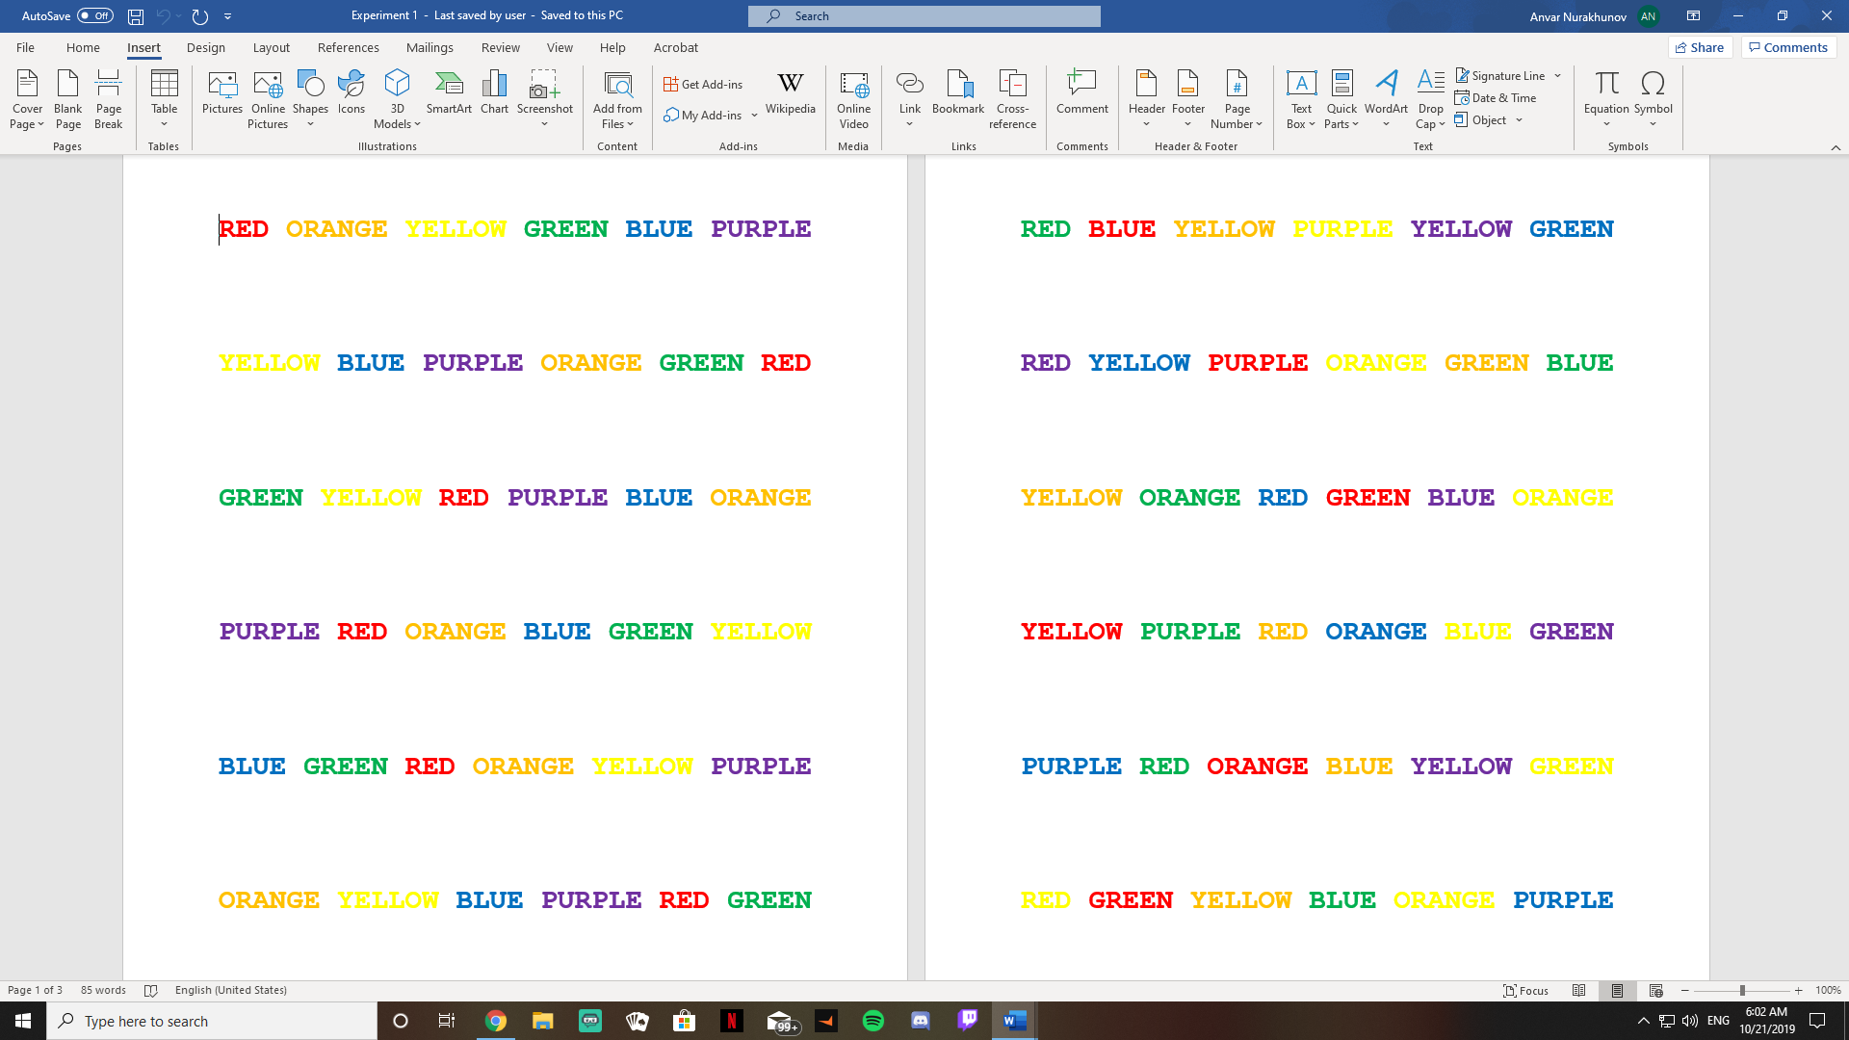
Figure 1. These were the pages used for the experiment. On the left page, the ink corresponds to the color, and on the right, they are mismatched.
Results
Who | Time for the first page (seconds) | Time for the second page (seconds)
Anvar | 11 | 17
Emma | 18 | 29
Jorge | 20 | 32
Mateusz | 19 | 33
David | 15 | 28
Alex | 17 | 35
Devin | 22 | 34
Dad | 21 | 112
Mom | 17 | 44
Figure 2. This is the table I created to record my findings. The first column is who partook in the experiment, the second column is their time for the first page, and the third column is the time they took for the second page.

Discussion
As can be seen in the table above, everyone took significantly longer to finish the second page where the ink didn’t correspond to the color that was spelled out. Two distinct groups take the test, mom and dad who aren’t fluent in English, and the rest of the seven people who are fluent in English.
The first seven people are all fluent in English, grew up in America, and are college students. Theoretically they all should’ve had similar times. The results proved that they did, with the average time difference between the first and second page being twelve seconds. The only significant outlier was Anvar’s time, but that can be attributed to the fact that he created the test and was more familiar with it. However, once more than one stimulus was introduced, everyone’s time was very similar.
The second group were the parents, who aren’t fluent in English, especially the dad who has a minimal knowledge of the English language. As a result, not only did they have to deal with an added stimuli on the second page, they also had to make an extra effort to internally translate the words. . In theory, they should take longer to complete the test, and they did with an average time difference between the two pages being fifty-nine seconds. As can be seen in the results, people take longer if they do not have a good grasp of the language. The time for the first page was very similar though with everyone though, which shows that just reading words is very easy for the brain.

Conclusion
In conclusion, my experiment proved the Stroop effect true because it showed that it takes significantly more time to say the color of the ink if the word doesn’t spell out the corresponding ink. I also found that a good knowledge of the language doesn’t affect purely reading, but when multiple stimuli are introduced people with poorer grasp of the language slow down significantly; my mom took almost thirty seconds more than me or Emma, and my dad took almost a minute more. As can be seen from the results, the reaction time slows down proportionally to the number of stimuli present.
References
- [1]“The Stroop Effect - The Stroop Effect - Is Your Mind Playing Tricks on You?” The Stroop Effect - The Stroop Effect - Is Your Mind Playing Tricks on You? - CloudDeakin, d2l.deakin.edu.au/d2l/eP/presentations/presentation_preview_popup.d2l?presId=67655.

