Engineering Scale
Nurakhunov Anvarjon
Grove School of Engineering, City College of New York, USA
Abstract: This paper will explain how to use an engineering scale to beginner engineering students. Engineering scale is a very important part of an engineer’s job, and it is important to know how to use it.
- Introduction
Creating construction drawings is the backbone of civil and structural engineering, and to make sure that the drawings area accurate, engineering scale is used to create them. Engineering scale is also used to accurately read the construction drawings made by other engineers. Engineering scale was invented when machine parts required greater precision that the architecture scale was able to give, which was invented first.
- Scale
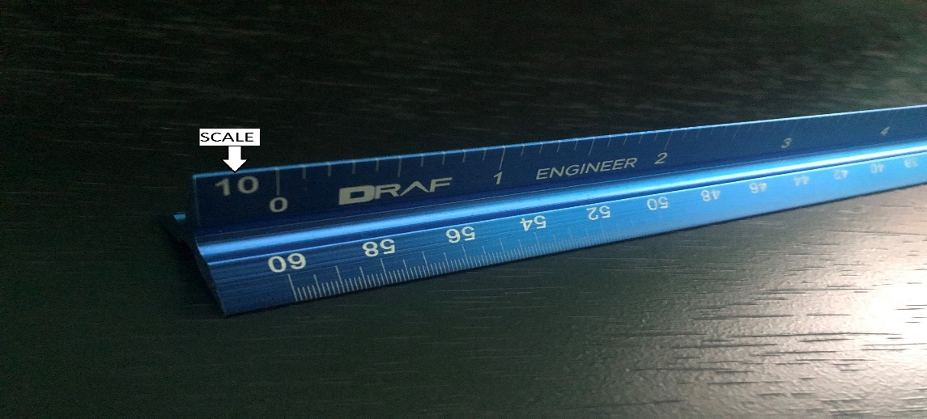
Figure 1. This picture shows one of the scales (1 inch equals 10 feet). You can also see that 1 inch equals an actual inch.
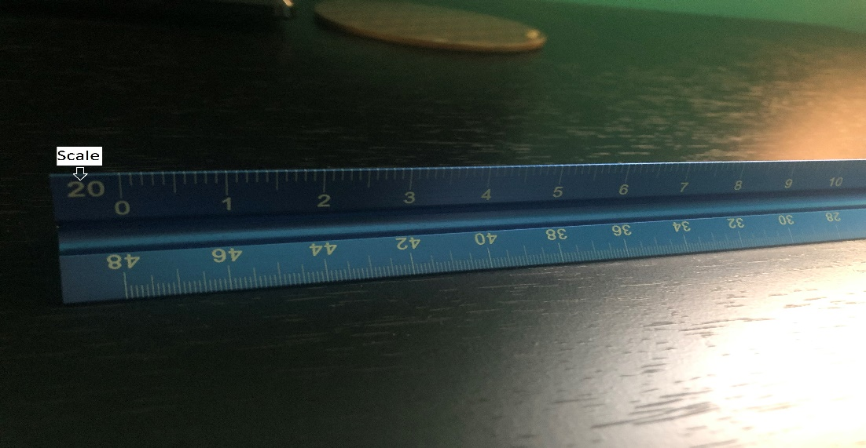
Figure 2. This picture shows a different scale (1 inch equals 20 feet). As you can see, the inches are much shorter here, and they continue to become shorter the higher you go up the scale, because they must always equal to 12 real inches, but they have to be scaled down for their respective scales.

An engineering scale has three sides, and each side has a scale, as can be seen in Figures 1 and 2. The engineering scale is twelve inches wide, but the number of inches written on the side changes depending on the scale. A scale indicates how many feet each inch is equal to, and it goes from 10 all the way to 60. As can be seen in Figure 2, there are more inches than on the scale of Figure 1, because each inch equals a higher number of feet. For example, on the scale of 10, each inch is equal to 10 feet, on the scale of twenty, each inch is equal to 20 feet and so on. [1]

- Steps
- First, you would need to find a drawing to measure the dimensions of. It’ll usually be a construction drawing of a building, or a room in a building.
- The scale to measure the drawing is usually indicated somewhere on the drawing
- Find the indicated scale on your engineering scale.
- The 10-30 scale are on one side of the ruler, and the 40-60 scale are on the opposite sides
- Measure the drawing from any two points that you desire.
- You should start measuring from the zero mark on the left and note where it ends on the right. There are always ten subdivisions on each side (each inch is divided into ten equal parts), regardless of the scale.[1]
- Take the number that you get, and multiply it by 10. That’s the final answer.
- You multiply the number by 10 regardless of the scale that you are measuring it on. The scale just lets you know how many feet each inch is equal to. [2]
- Example
Let’s say we are measuring an object, and it is given that each foot is equal to 20 feet. We find the 20 scale on the ruler as seen in Figure 2, and measure the object from tip to tip. We read the measurement as 14.1, and we come to the last step. We have to multiply the number by 10 to get the final reading. In our case, it is 141 feet. So the final answer is that the object, on the scale where 1 inch is equal to 20 feet, is 141 feet in length.

- Conclusion
The purpose of using the engineering scale is to be able to accurately read the construction drawings, or to draw them. It is very important to practice doing it until you can use it fast and effortlessly, because the faster the project is done the better.

References:
Website:
[1] Hageman, Laura. “How to Measure Foot Size.” Sciencing, 2 Mar. 2019, sciencing.com/measure-foot-size-5522771.html.
[2] Using Engineering and Architect Scales. www.usfa.fema.gov/downloads/pdf/nfa/engineer-architect-scales.pdf.

